  - Intro to Freelance and Python Tools

- Asana timeline link:
https://app.asana.com/1/1212894545388731/project/1212894614281663/list/1212894631362360
- Reflect on what challenges you might encounter while working on this project as a freelancer.
  - What are the pros and cons of working on your own timeline?
  - What strategies will you use to hold yourself accountable?
  - Write 150 to 200 words about your thoughts on this Exercise’s content in a text document.

- Working on my own timeline allows me to prioritize adequate rest, such as sleeping eight hours a day, having calm mornings, going for walks, and taking longer breaks when needed. It can also provide flexibility, including the possibility of longer weekends.
On the other hand, working independently requires consistent self-discipline, self-motivation, and the ability to reward progress fairly. Without external structure, there is a greater responsibility to establish clear milestones and realistic timelines. Regular self-assessment is therefore essential to ensure steady progress and avoid losing direction.

- To hold myself accountable while working independently, I plan to break the project into clearly defined milestones and small, achievable tasks with specific completion criteria. I will use time-boxed work sessions to maintain focus while preventing fatigue, and I will track progress through regular updates in a simple project log.
When distractions arise, I will write them down rather than act on them, allowing me to stay present with the task at hand. Finally, I will schedule brief self-check-ins to review progress, adjust my approach when needed, and clearly define when tasks are complete, helping me stay consistent without relying on rigid schedules or self-pressure.

- Done!

- Install JupyterLab and explore its functionalities. Reflect on what you notice in terms of differences (good or bad) compared to Jupyter Notebook. Take a screenshot of a JupyterLab session and paste it into your text document.
CON: It seems I can only open JupyterLab opening Anaconda Prompt.
PROS: It’s useful to have jupyter notebooks and text files opened in one environment.
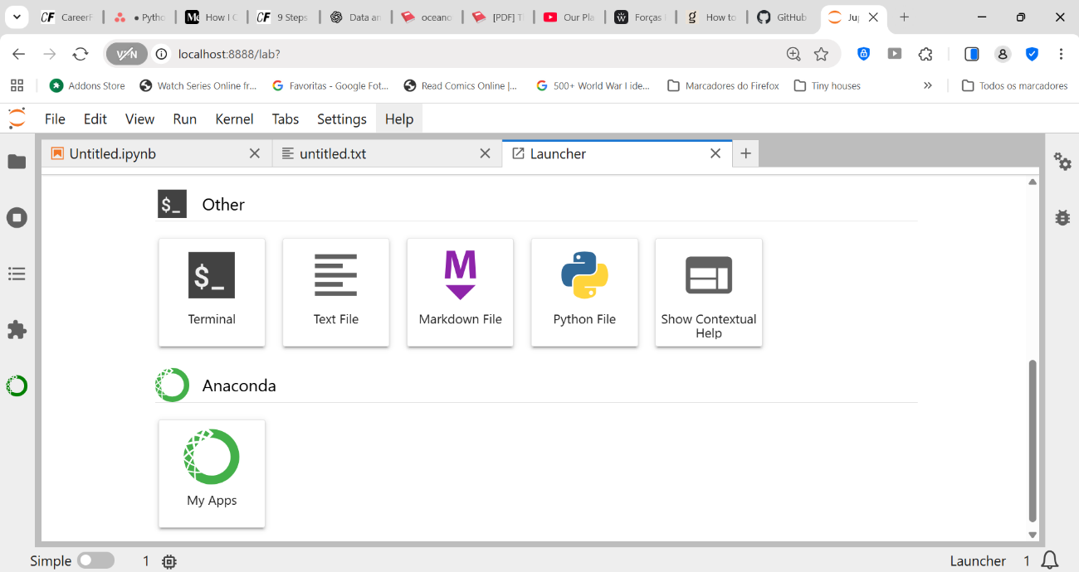

- Get started with Google Colab and try executing some basic code, for example, some basic addition and division between numbers. Take a screenshot of the notebook and paste it into your text document.
I have used Google Colab during the last Python Achievement. I needed more RAM and using Anaconda wasn’t working. I really enjoyed using it and barely felt any difference. I eventually moved to Kaggle because it has even more RAM to use.
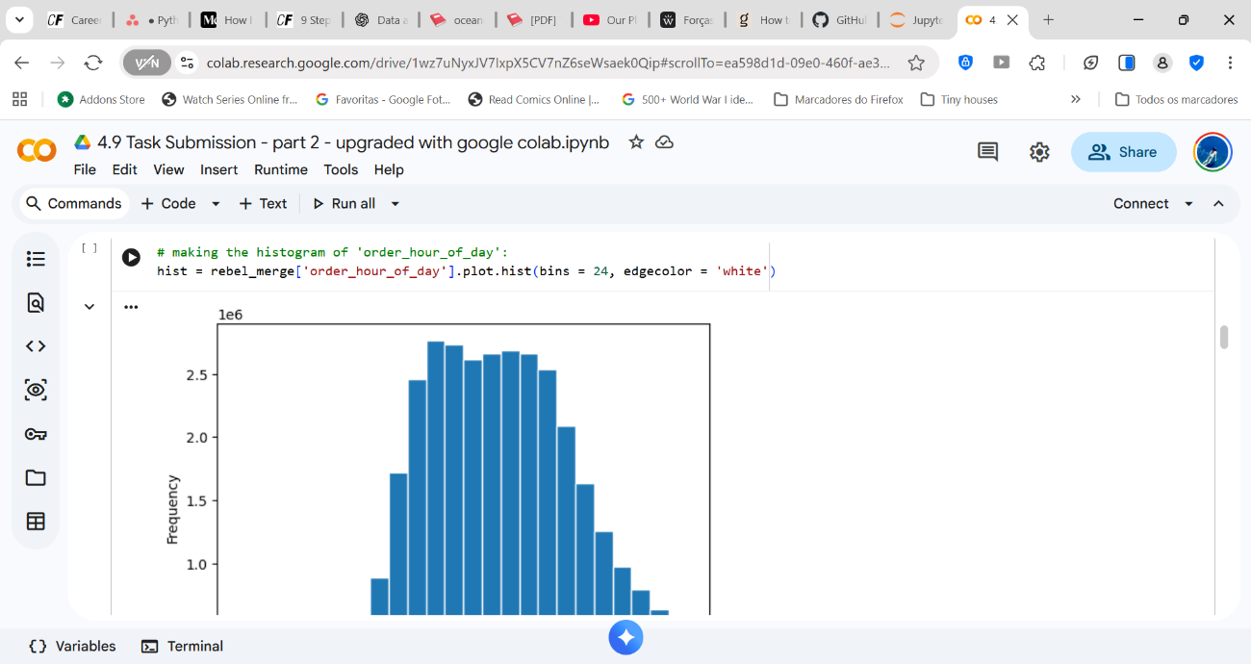
- Write 150 to 200 words about the pros and cons of using JupyterLab and Google Colab in your text document. Create a scenario where you think JupyterLab would be the best tool to use, then do the same for Google Colab.
For the time being, I feel I could use both interchangeably, although I know a session in google colab can only be maintained for 12h, whilst in Jupyter there’s no such constriction.
Google Colab can also be an interesting tool to edit/work on the same notebook with several people in real time, since it runs on a cloud.
Jupyter runs locally, so there’s no need for internet, which can be ideal for sensitive data.

